# 

# 1- Product Vision & Domain

# What is Intercom? Conversational Relationship platform with online customers

Powerful automation technology powers our bots for sales, and support, amplifying the impact of the team and automating simple actions like recommending help content to resolve queries

## Onboard and support your customers with the team you already have. Intercom puts y our customer messaging in one place.

Intercom is one of the most well-known customer support tools on the market.But what makes it so popular? Well, many people have heard that Intercom offers one of the most comprehensive sets of tools for a modern business to cover its customer service needs.

* Why is it Unique?

how much do you want to switch between all those tools to manage your customer communication channels and campaigns. It can hardly help in providing a stellar experience to your clients. That’s what makes Intercom so great. They have it all in one dashboard, and they know how to sell it

# 2- Product Current Features

* Intercom is a great comprehensive tool offering live chat, help desk, knowledge base, and email automation features. It’s also quite famous for its well-developed chatbots and convenient product tours for customer onboarding.
* Introduction to Custom Bots

Create the perfect bot that helps you crush your number, qualify more leads and book more meetings around the clock.

* Onboard and activate customers with targeted outbound engagement.
  + Use Product Tours to create a series of onboarding steps or to announce a new feature.
  + Create targeted messages and campaigns to deliver the right message to the right customer.
* Mobile Carousels ?

## Improve retention rates, share product announcements, and onboard with ease—all in your mobile app.

## If you're experiencing a spike in customer conversations right now, Intercom can help. Learn how to:

* Highlight timely FAQ content with the Content Showcase app.
* Automatically route conversations with custom bots.
* Instantly answer your customers’ common questions with Resolution Bot.
* Rely on saved replies to keep your team in the loop and up to date.

## Customizing your Messenger ensures it looks right at home on your app or site. Learn how to:

* Customize the experience for your users, leads and visitors.
* Set the controls for your workspace.
* Track user data

Track user data to see who your customers are and what actions they take in your app. Filter, segment, and reach out to your customers using information tailored to your business.

# Forward your emails and social messages

# Automatically send emails and social media channels to teams or teammates in Intercom so you can handle all support requests from your team inbox.

* Design an inbound Custom Bot
* Create ongoing messages

With ongoing messages, you can create messages that send to those who match your filters now and in the future. Just choose:

Your message type,

Who your audience is,

When you want it to send and

How do you want to measure performance?

* Faster customer resolutions
  + Custom Bots ask the right questions to automatically prioritize and route new conversations for more efficient support.
* Complete customization
  + Chatbots connect to your tech stack, automate workflows behind the scenes, and act as extensions of your sales and support teams.
* More leads, 24/7
  + Bots work for you all day, every day—starting conversations, asking questions, and delivering qualified leads when they're live on your site.
  + 24/7 automated support with Resolution Bot
  + Complete self-service: Our chatbot uses machine learning to accelerate resolution times for your customers—even if your team is busy or offline.
  + Easy-to-train automation: Resolution Bot automatically recognizes similar questions from past conversations to serve up the answer you deem best.
  + Goodbye repetitive work: Let our chatbot respond to questions that get asked over and over, so your team can focus on more productive tasks.
  + Use it as soon as customers start typing: Speed up self-service by offering relevant answers based on what customers are typing—before they even hit the enter key.
  + Bots in different languages and time zone: Make 24/7 global support easier for your team by automating answers in 32 languages. Your team doesn’t have to be online for our bots to start conversations, route qualified leads, and collect customer info for you.
  + Code-free and hassle-free chatbots: Build a bot in minutes that lightens your team's workload—collecting information, triaging conversations, or even answering questions.
  + Improve how your business operates: Whether you use our out-of-the-box reports, customize your own, or use our APIs and apps, you can measure exactly what’s important to your business with maximum flexibility.
  + Apps & integrations 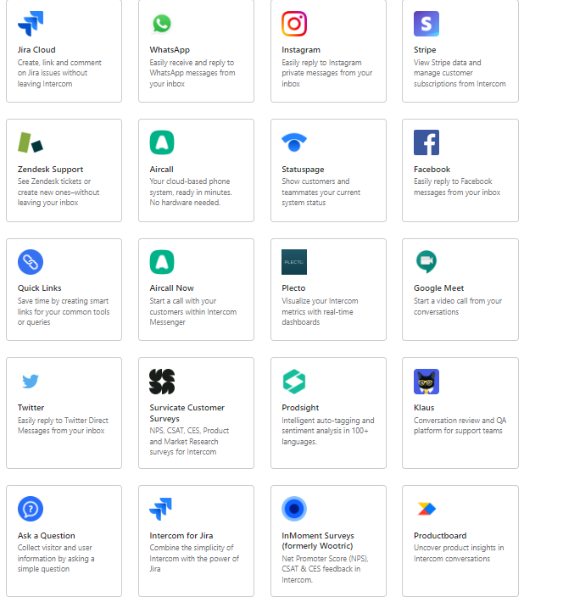

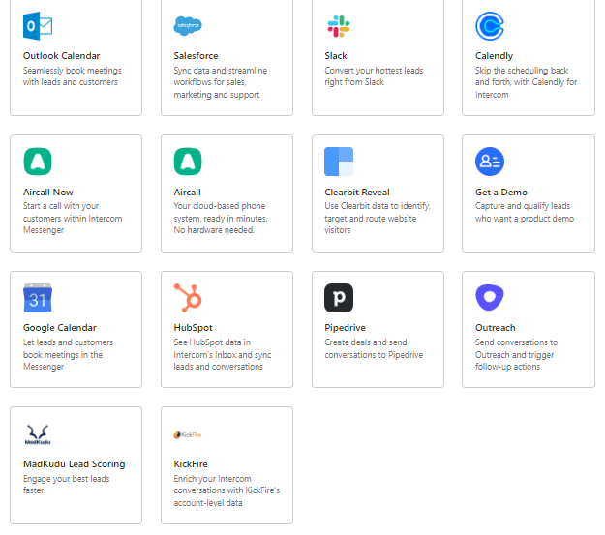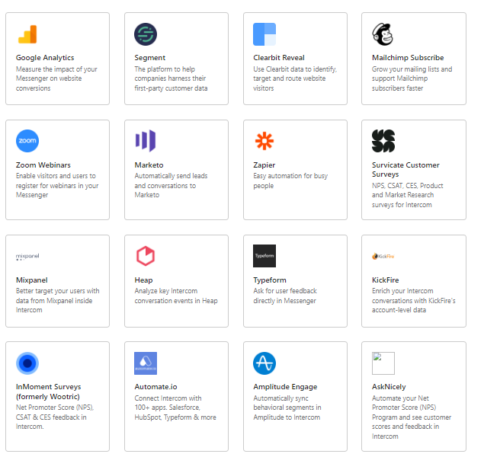

* Goals & constraints
  + Proactive communication: it’s good thing to reach your customer quickly and make sure that they have the information they need
  + Automatically route conversations with custom bots
  + Instantly answer your customers’ common questions with Resolution Bot.
  + Rely on saved replies to keep your team in the loop and up to date.
* User & Use Cases

CRMCustomer - IteractionCustomer - MessagingCustomer - SupportLive Chat

* Prioritize user case
* Brainstorming solutions

# 3- Product competitors

* Intercom competitors for support, marketing, and sales: **HelpCrunch, Crisp, Help Scout**.
* Intercom competitors for live chat: **Olark, LiveChat, Smartsupp, GoSquared**.
* Support-oriented Intercom competitors: **Zendesk, Freshworks, LiveAgent, Lemtalk**.
* Marketing- and sales-oriented Intercom competitors: **Drift, Customerly**.

1. **HelpCrunch** :

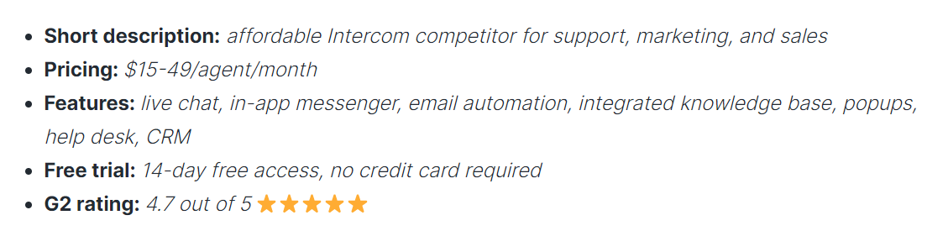

HelpCrunch stands out from all the other Intercom competitors because of its versatility and affordable prices. But the tool also offers some extra features that you won’t find in Intercom.

With the ‘Standard’ subscription plan, you get a fully customizable live chat, help desk, and knowledge base for your customer support. By the way, the latter is available right from the chat widget. So the visitors will be able to find some answers themselves without any bustle from your side.

**Top 10 Alternatives & Competitors to Intercom**

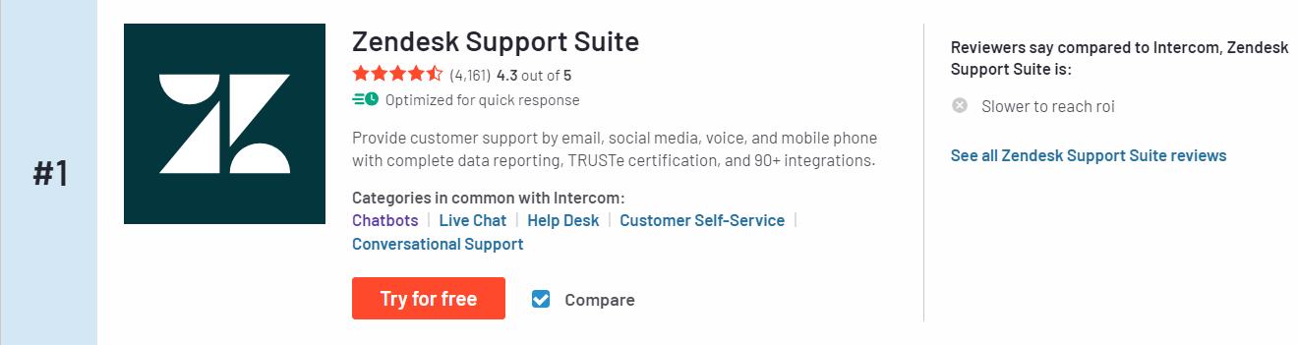

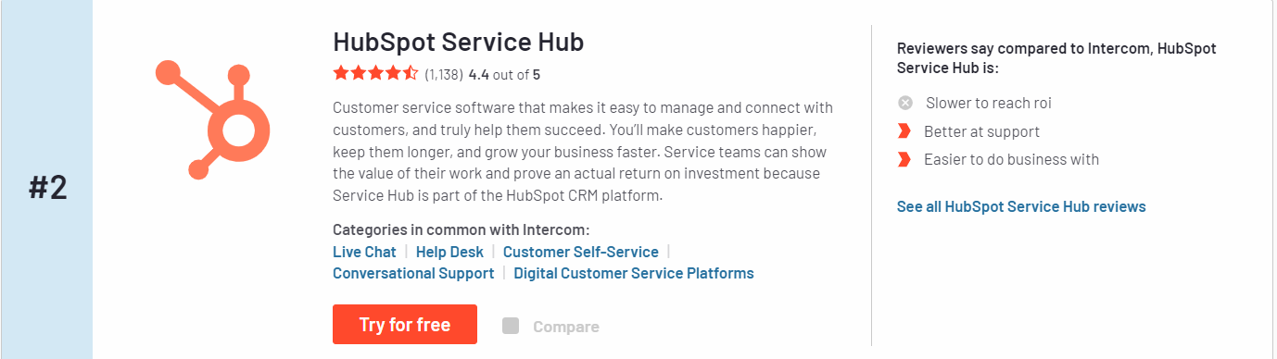

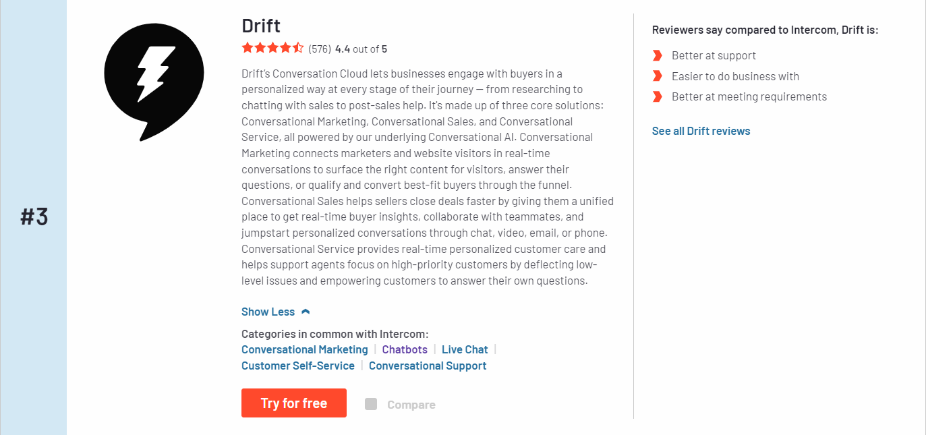

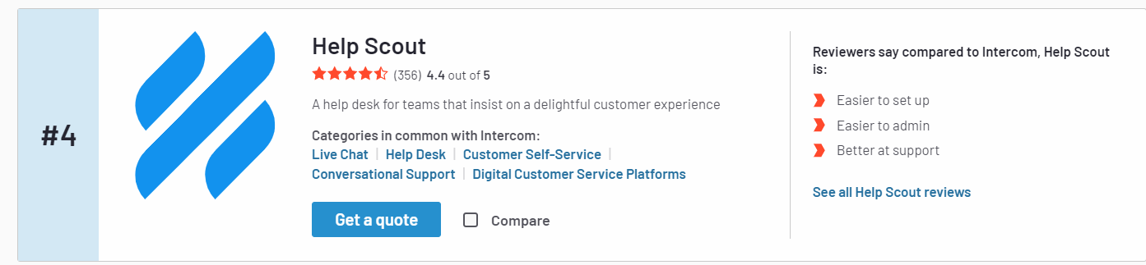

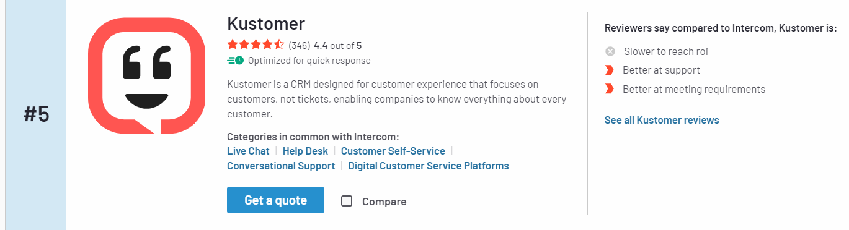

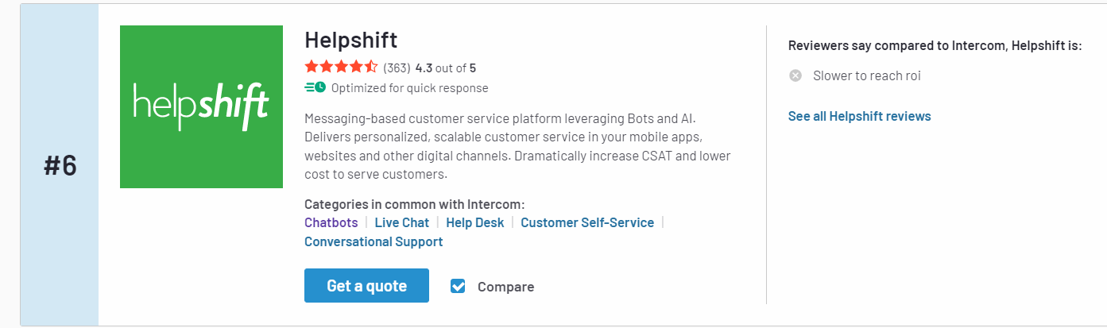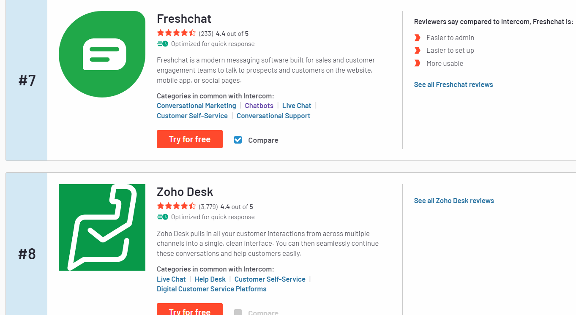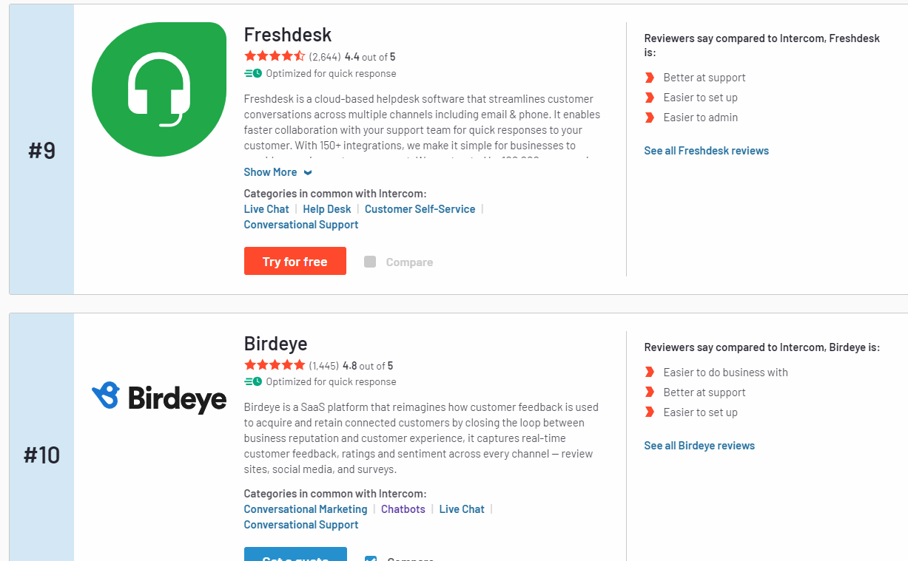

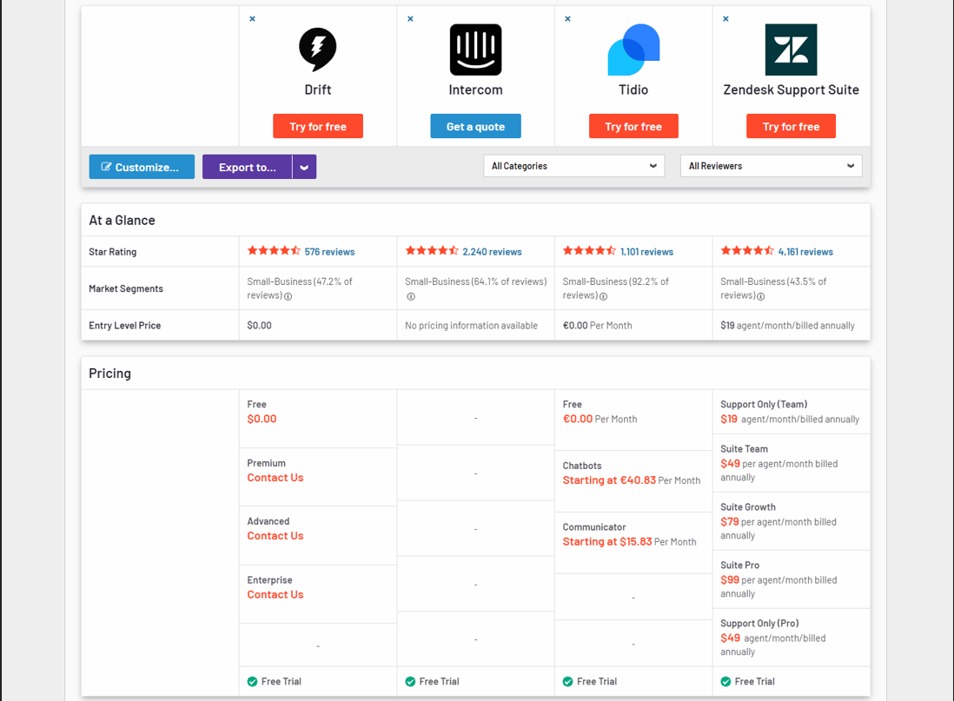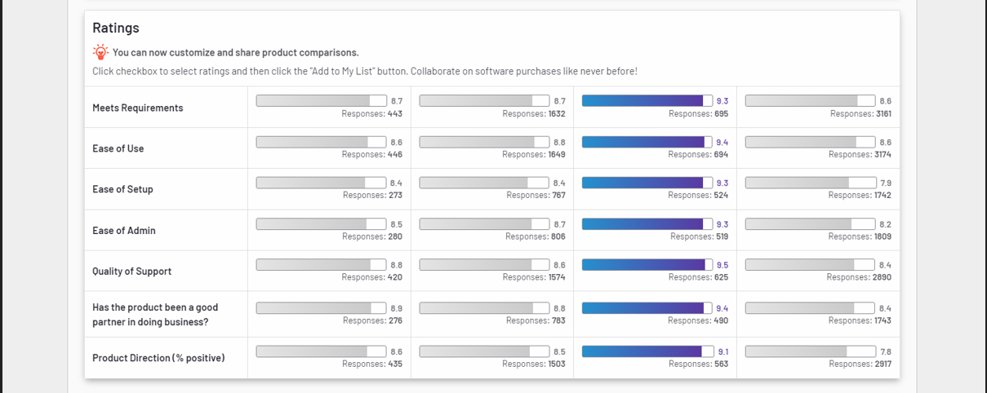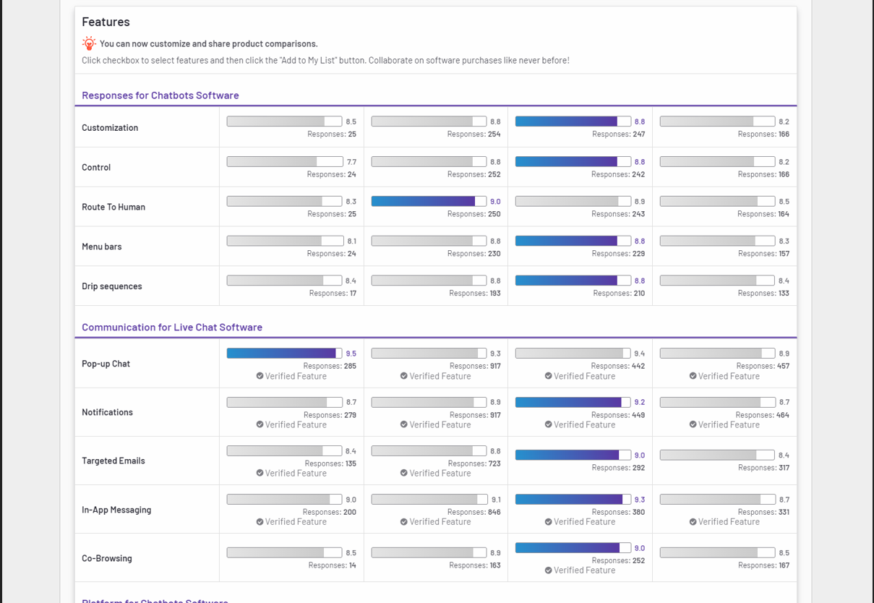

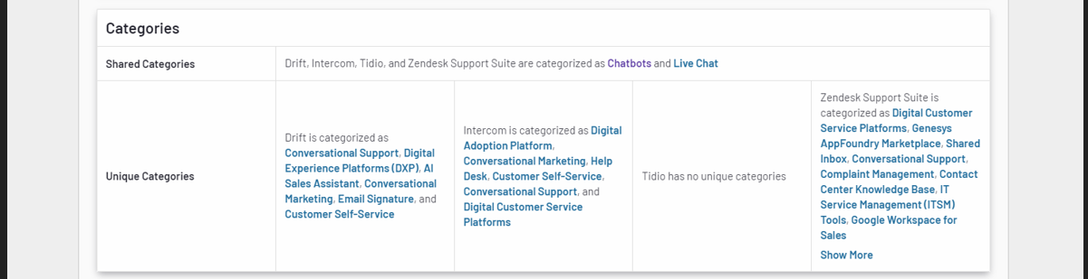

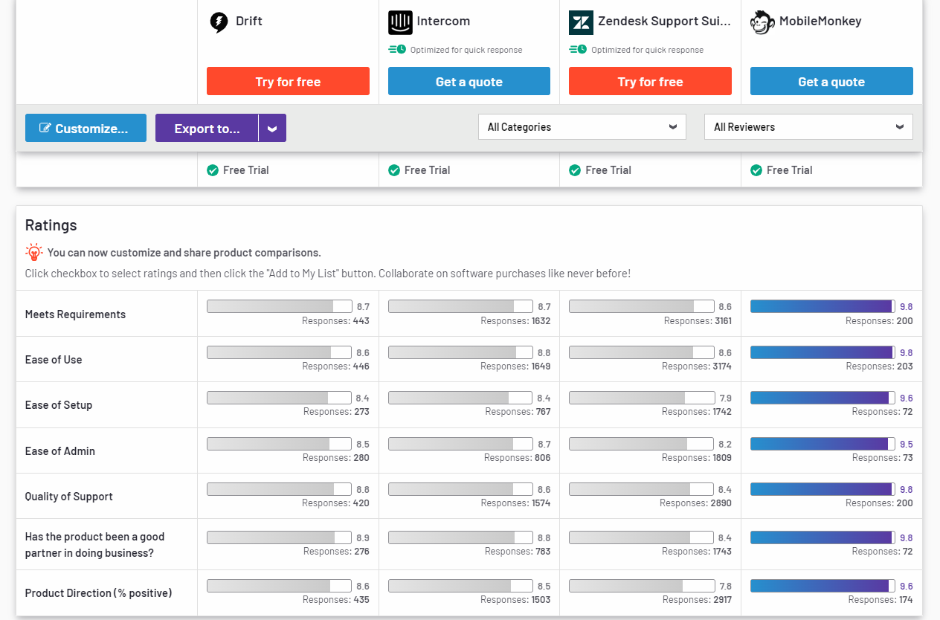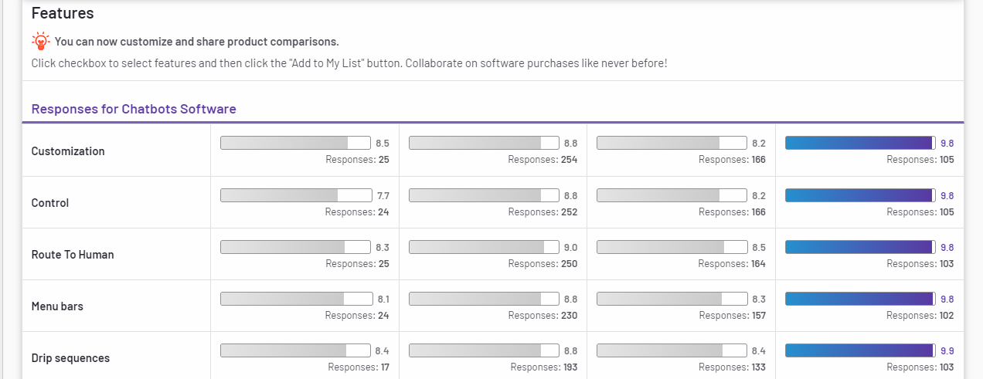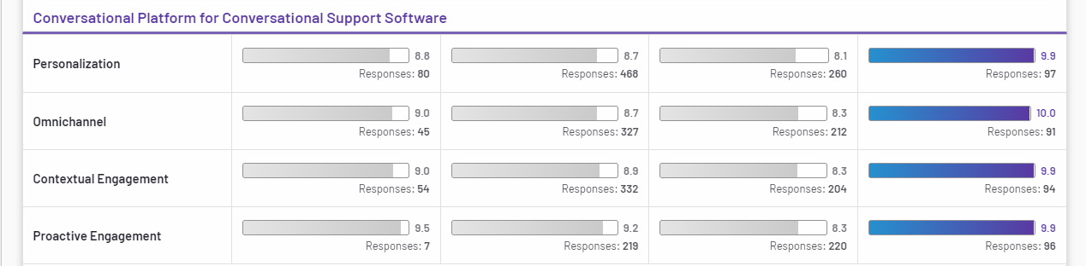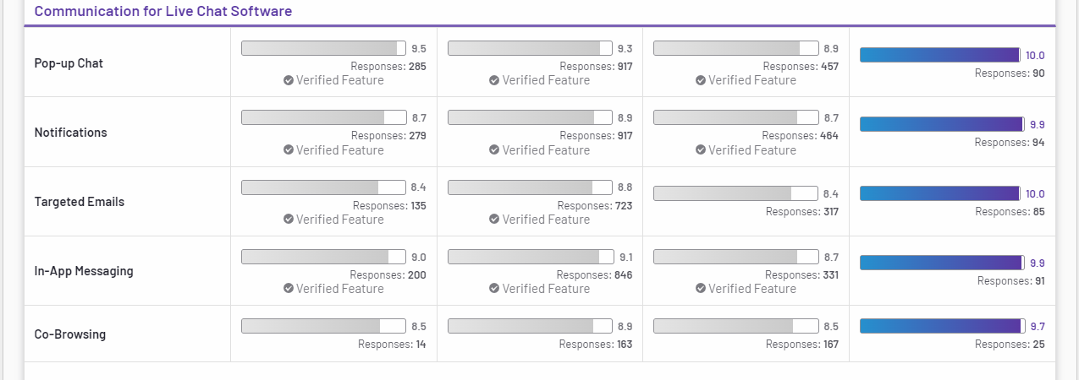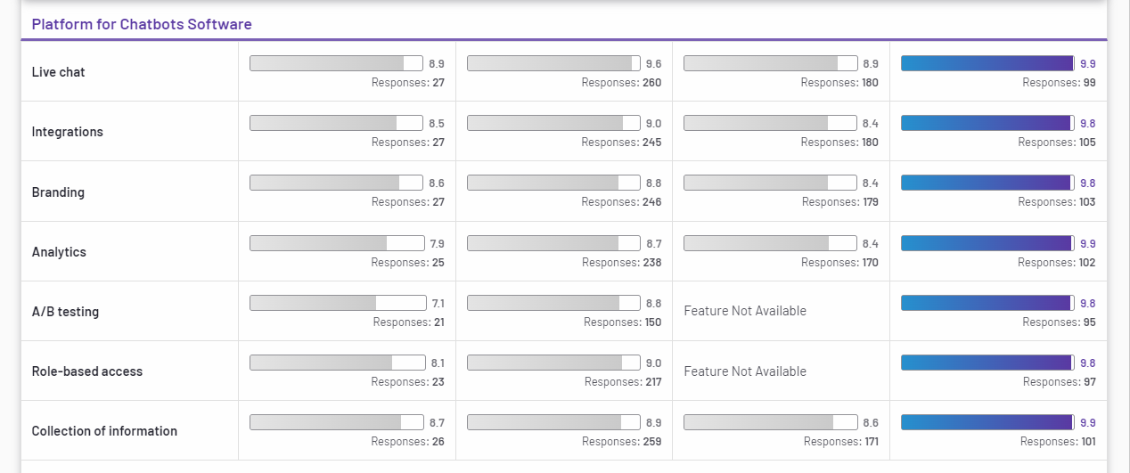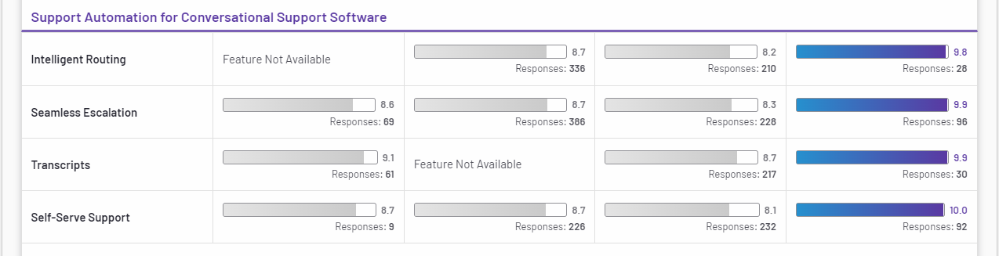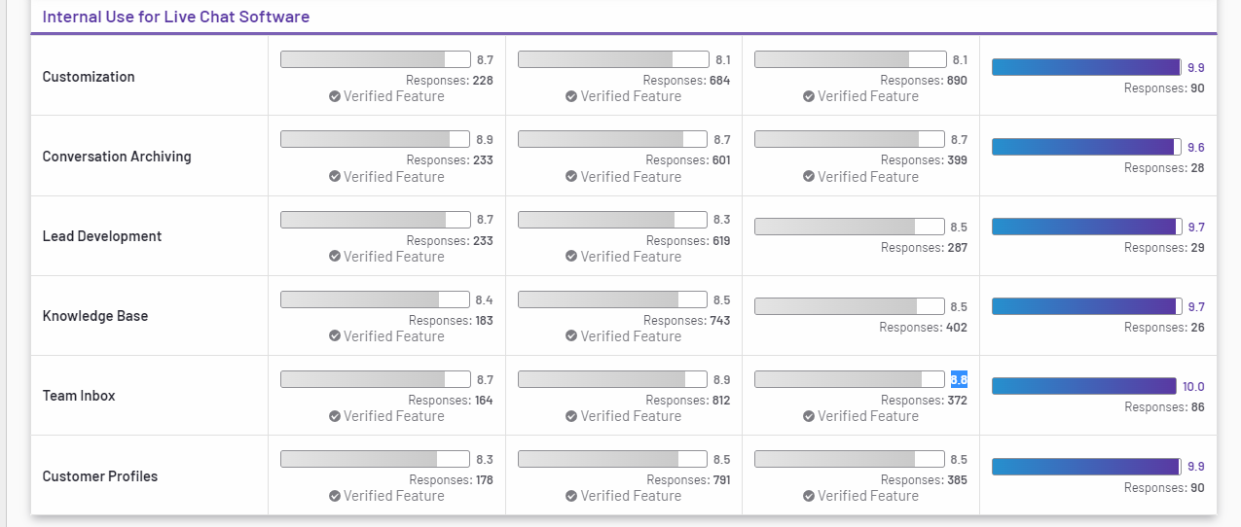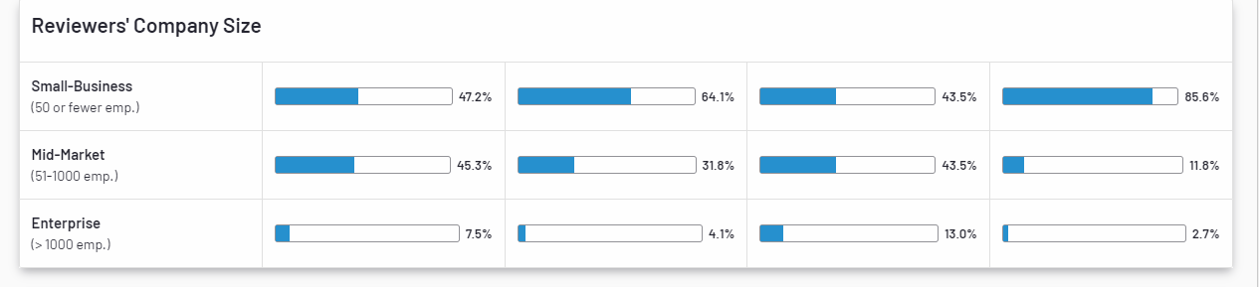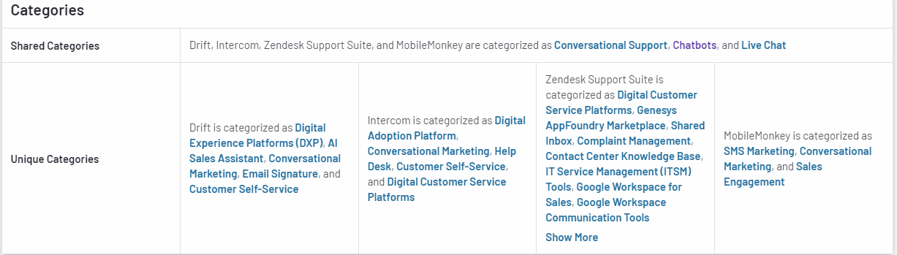

# 4- Product Problems

* The pricing system is way too complex to predict ,and very high range pricing Intercom pricing consists of several elements
* Numerous complaints about their email automation tools. I’ve seen many reviews mentioning that Intercom is a decent support tool that sucks at email marketing
* Smaller issues like no easy way to merge conversations, limited customization, minor bugs, crashes, or a subpar mobile app.
* Lack of support (support must be 24/7)
* Easy use & understanding how to use functions in the product quickly.
* Overpricing product
* Customer support, overpriced product, low customisation abilities, not suitable for enterprise scale
* Need to integrate with AI Chatbot for Increasing the demand for self-service
* 24/7 customer assistance at low operational costs.

# 5- Product Solution :

* It should have a clear and transparent pricing policy that is easy to predict and scale
* It should provide a stable and reliable experience, with a customer support team that’s always happy to help.
* [AI chatbots are the best](https://www.advertisemint.com/3-uses-facebook-messenger-bots-improve-business/) available solution for businesses for increasing user engagement , Service More Customers at the same time without any cost besides it can gather data and create details reports on customer behavior and preference for improving the service and Get the Best Customer Experience

# 6- Best Natural Language Understanding (NLU) Software for AI Chatbot

# Amazon, Microsoft Azure (LUIS), Google Cloud AI, IBM Watson : are four leading cloud MLaaS (Machine learning as a service (MLaaS)services that allow for fast model training and deployment.

# 

* Recommend Using LUIS ( Language Understanding Intelligent Service) because :

1. Simplicity . With only a few clicks you can build your own conversational AI application. You can build your custom application by following one of our quickstarts
2. Security, Privacy and Compliance: Backed by Azure infrastructure, LUIS offers enterprise-grade security, privacy, and compliance. Your data remains yours; you can delete your data at any time. Your data is encrypted while it’s in storage.
3. Integration: easily integrate your LUIS app with other Microsoft services

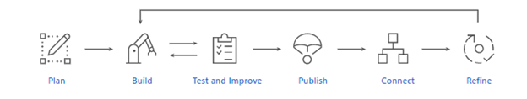

# 

# 8- Product AI Chatbot Suggested features

1. All site features should be reachable through chatbot AI.
2. According to the user journey, the user has two options (AI chatbot and live agent).
3. At the end of each customer conversation, Gathering customer feedback via an AI chatbot.
4. Obtain a Net Promoter Score (NPS) based on chatbot usage by customers ( at least 5 times per month).
5. Customers can evaluate product features using an AI Chatbot.
6. Customers can request a demo from the AI chatbot.
7. Display the number of conversations conducted via AI chatbot for customers to demonstrate the value of using AI chatbot and to increase user engagement.
8. Using ML emotion recognition, an AI chatbot can recognize emotions.
9. AI chatbot can recognize the voice
10. improve utterances of user journey based on BI
11. Reduce user waiting time to less than 30 seconds (KPI)

# 9- How to increase user engagement By using AI Chatbot

AI Chatbot Benefits for Customers

1. **24/7 Availability** – Customers needn’t wait for the next available operator when chatbots are part of the communication strategy on a round-the-clock basis.
2. **Instant Response** – Chatbots can handle the queries of thousands of customers instantly as well as simultaneously and improve the average response time.
3. **Consistency in Answers** – The use of chatbots can help businesses maintain a great level of consistency in answers and improve customer experience with the product features
4. **Enriching the user experience** – can ensure a touch of personalization by engaging customers with one-on-one conversations, maintaining a natural-sounding tone, and by being good at interactive communication.
5. **Multilingual** – Your business can program the sales bot to answer queries in the language of customers
6. Deliver consistent responses to avoid providing irrelevant information to customers.
7. Relevant and quick responses are delivered to the customer.
8. One-on-one responses – Customers expect immediate one-on-one responses and you can use an AI chatbot to meet that goal

# 10- SRS

1.1 All site features should be accessible through chatbot AI.

| **Feature Name:** All site features should be accessible through chatbot AI. | |
| --- | --- |
| ID | AIChatbot1.1 |
| Priority |  |
| Description | **As a customer,**  **I want to** use the chatbot to access any site features, I simply type any feature into the chatbot, and the chatbot directs me to the appropriate page.  **So that** the chatbot navigates me without searching. |
| Actors | Customer |
| Acceptance Criteria | 1. A customer can access any site feature from the chatbot by typing the site feature and the chatbot navigates without searching. 2. If a chatbot can’t determine a user's input, then we can display a list of suggestions that’s nearest to the user's input and show options for the user to get connected to a live agent and customer's input is then saved for BI investigation (to check if customer’s input needs to be added to training data or not). |
| Definition of Done | * Unit tests passed * Acceptance criteria met * Code review * Passed: Functional tests passed * Non-functional requirements are met. |
| Owner |  |
| Iteration | Unscheduled |
| Estimate | 5 points |

2.1 According to the user journey, the user has two options (AI chatbot and live agent).

| **Feature Name:** According to the user journey, the user has two options (AI chatbot and live agent). | |
| --- | --- |
| ID | AIChatbo2.1 |
| Priority |  |
| Description | **As a customer,**  **I want** to be able to choose between speaking with a live customer support agent and continuing with the chatbot agent.  **So that** chatbot directs based on the customer's responses. |
| Actors | Customer |
| Acceptance Criteria | 1. If a customer could simply ask the chatbot to connect them to a human customer support agent, they could be talking to an agent in seconds. 2. If not, the customer will proceed with the chatbot agent. |
| Definition of Done | * Unit tests passed * Acceptance criteria met * Code review * Passed: Functional tests passed * Non-functional requirements are met. |
| Owner |  |
| Iteration | Unscheduled |
| Estimate | 3 points |

3.1 At the end of each customer conversation, gather customer feedback via an AI chatbot.

| **Feature Name:** At the end of each customer conversation, gather customer feedback via an AI chatbot. | |
| --- | --- |
| ID | AIChatbot3.1 |
| Priority |  |
| Description | **As a customer,**  **I want** to rate services and provide feedback whenever I finish a chat with a human agent or AI chatbot.  **So tha**t the quality of service can be improved by time. |
| Actors | Customer |
| Acceptance Criteria | 1. A customer can answer whether the support is effective or not. 2. A customer can rate the speed of support whenever they finish a chat with a human agent or AI chatbot. 3. If a customer has any suggestions for improving the service, he or she can leave a comment. |
| Definition of Done | * Unit tests passed * Acceptance criteria met * Code review * Passed: Functional tests passed * Non-functional requirements are met. |
| Owner |  |
| Iteration | Unscheduled |
| Estimate | 3 points |

# 11- Wireframes

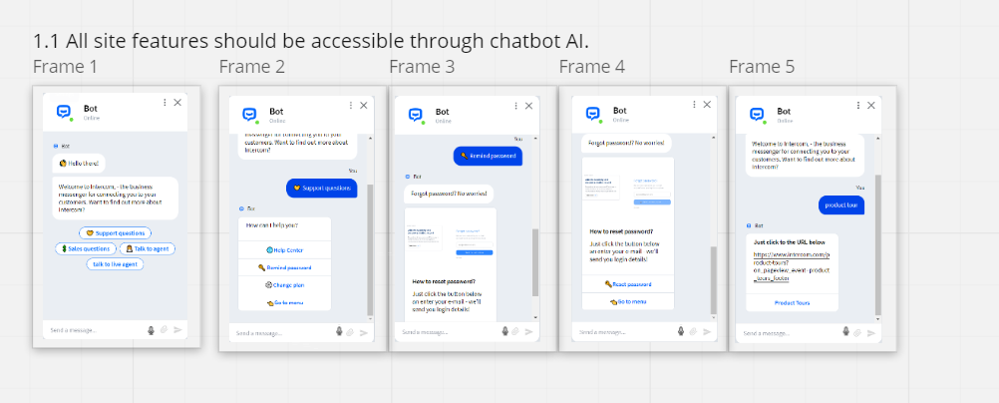

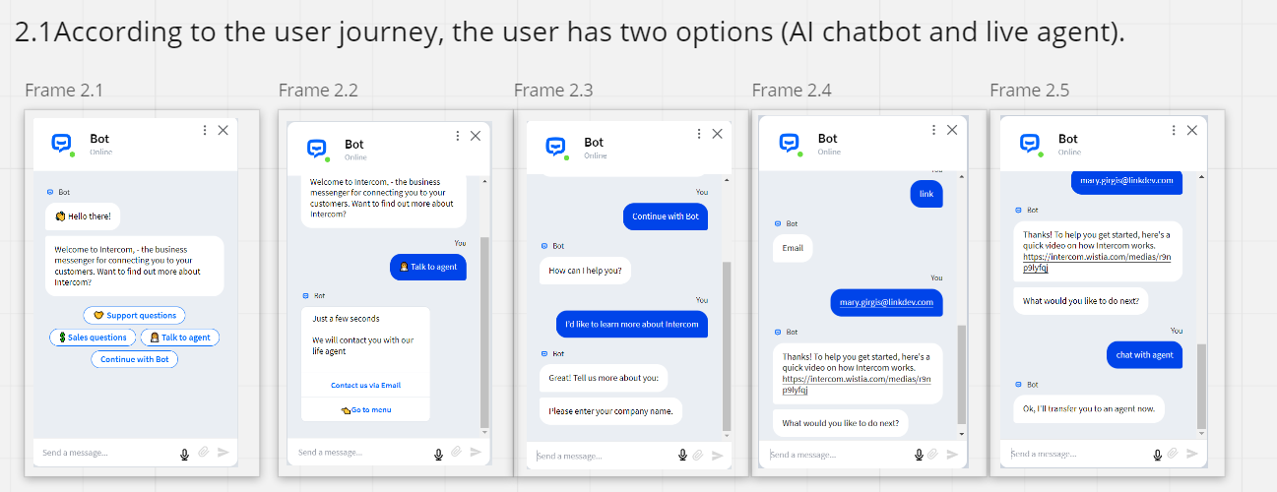

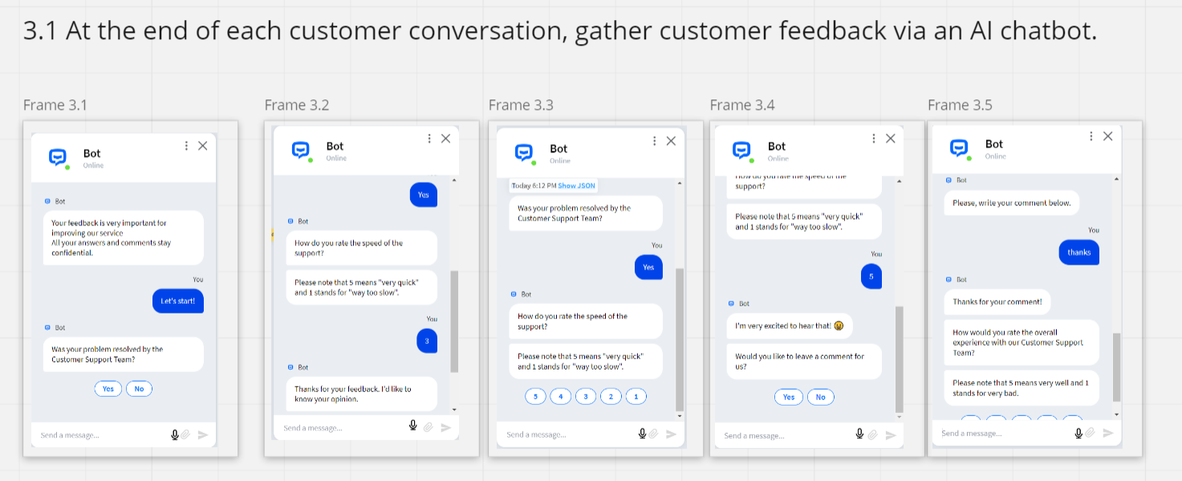

# 12- use case.

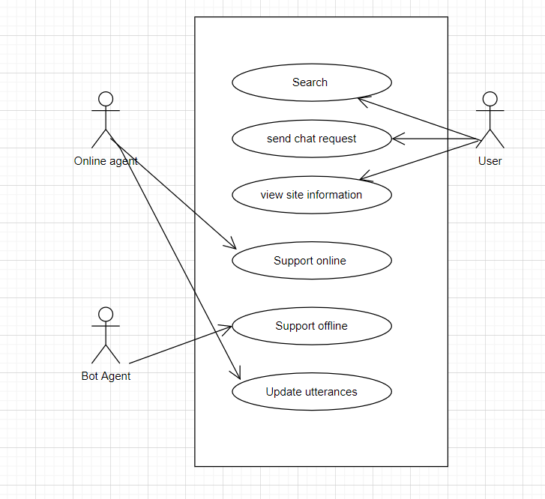

13-Conversation Flow

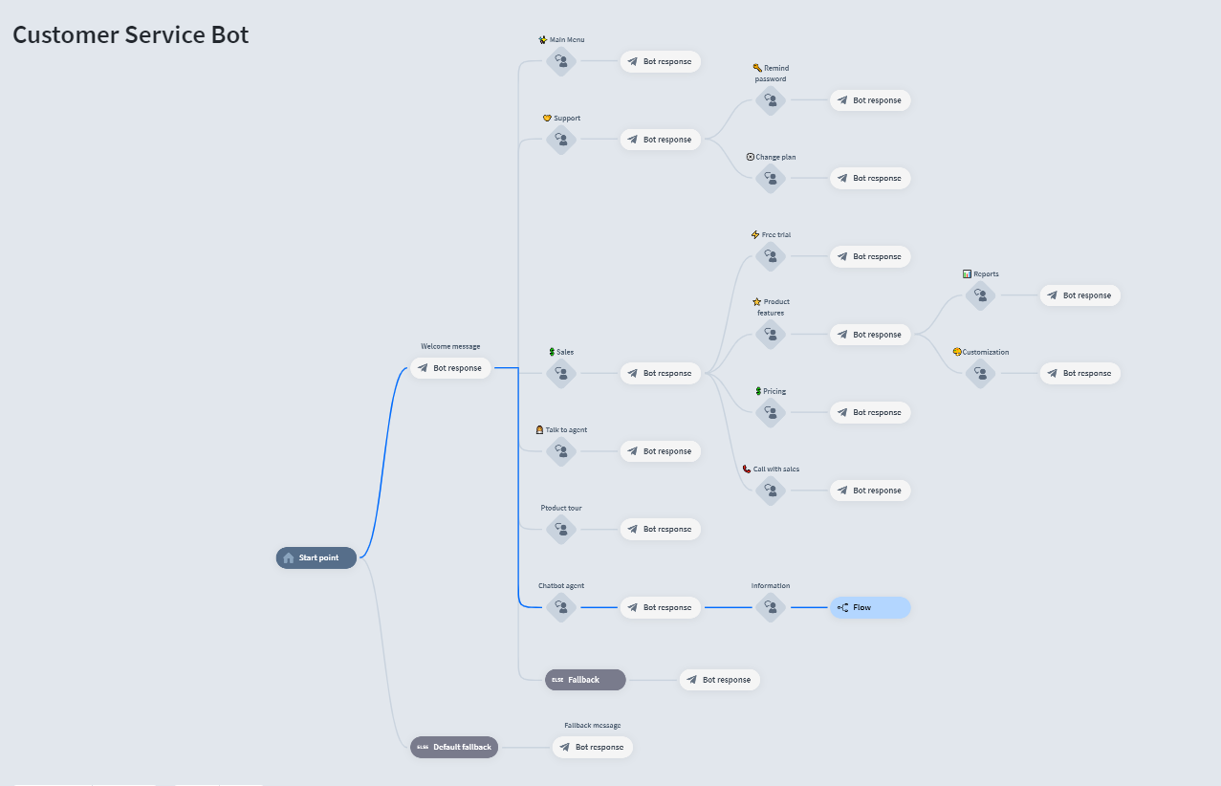

# 

# 

# 

# 

# 

# 14-metric

# 15- references

<https://www.intercom.com/resources/demos/intro-to-operator>

<https://www.intercom.com/resources/demos/intro-to-the-messenger>

<https://www.intercom.com/resources/demos/intro-to-custom-bots>

<https://www.intercom.com/resources/demos/mobile-carousels>

<https://www.intercom.com/resources/demos/what-is-intercom>

<https://www.intercom.com/resources/demos/tips-for-using-intercom-to-help-with-your-covid-19-response>

<https://www.intercom.com/resources/demos/intro-to-onboarding>

<https://www.intercom.com/resources/demos/customize-your-messenger>

<https://www.intercom.com/resources/demos/track-user-data>

<https://www.intercom.com/resources/demos/forward-your-emails-and-social-messages>

<https://www.intercom.com/resources/demos/design-an-inbound-custom-bot>

<https://www.intercom.com/resources/demos/create-an-ongoing-message>

<https://www.intercom.com/automated-answers?on_pageview_event=automated_answers_footer>

<https://helpcrunch.com/blog/intercom-competitors/>

<https://www.g2.com/products/intercom/competitors/alternatives>

<https://www.g2.com/compare/birdeye-vs-drift-vs-freshworks-freshchat-vs-zendesk-support-suite>

<https://www.g2.com/compare/drift-vs-intercom-vs-tidio-vs-zendesk-support-suite>

<https://www.g2.com/compare/drift-vs-intercom-vs-zendesk-support-suite-vs-mobilemonkey>

<https://www.gartner.com/reviews/market/social-customer-service-applications/vendor/intercom/reviews?marketSeoName=social-customer-service-applications&vendorSeoName=intercom&sort=-helpfulness>

<https://www.g2.com/categories/natural-language-understanding-nlu?utf8=%E2%9C%93&order=g2_score>

<https://www.altexsoft.com/blog/datascience/comparing-machine-learning-as-a-service-amazon-microsoft-azure-google-cloud-ai-ibm-watson/>

<https://yourtechdiet.com/blogs/best-ai-tools-in-market/>

<https://www.netguru.com/blog/ibm-watson-vs-google-cloud-vs-aws-vs-azure>

<https://docs.microsoft.com/en-us/azure/cognitive-services/luis/what-is-luis>

<https://www.luis.ai/>